BT4222 — Mining Web Data for Business Insights
Final Project Report

Personalised Product Search on JDSearch:
A Dual-Horizon Re-Ranking System Driven by Log-Retention Dynamics

Group No. 13
National University of Singapore | Professor Wang Qiuhong

Chow Ee Xiang | A0300297J
Ethan John Ong Jian-Hao | A0308681Y
Heng Ann Xin | A0282911E
Ku Jia Yi | A0300567J
Lara Muy Steffany Mishell | A0350365H

Abstract
Business objective & RecSys formulation. We build a personalised re-ranking system for JDSearch (173,831 users, 15.5M query–candidate pairs, 26.7M interactions from JD.com). For each search query the system re-orders the supplied candidate slate (median 90 products) so that products the shopper later clicks, carts or purchases rise to the top, using the current query, product metadata and the user's preceding multi-behaviour history. Ground truth is the ordinal candidate label (0 none / 1 click / 2 cart / 3 purchase); success is NDCG@10, MRR@200 and P@1.
Prior baseline & critical diagnosis. We reproduce the collaborative-filtering family (NCF, NMF/SVD) used by past projects and show it is structurally mismatched to JDSearch: test queries are almost always new, 80.5% of catalogue products never appear in any history, and each user contributes a single test record, so ID-based CF collapses to near-random (NCF NDCG@10 0.086 vs. random 0.083).
Group contributions & modelling highlights. Tracing the history timeline back in time (per the instructor's prompt) we uncover a telescoping log-retention window — clicks are retained only ~7 days, carts ~90 days and orders ≥1 year — which means interaction TYPE is confounded with RECENCY. This reframes feature engineering: recent clicks/carts encode short-term query intent, whereas old orders encode long-term brand/category preference. We engineer horizon-aware features and design a Dual-Horizon Attention Ranker (DHAR) that separates these two roles with candidate-category attention.
Evidence-backed quantitative insights. DHAR reaches NDCG@10 0.336 / MRR@200 0.351 / P@1 0.229, beating LambdaMART (0.313), SVD (0.274), popularity (0.270) and all weak baselines. Diagnostics show the model ranks eventual purchases highest (median rank 7) vs. clicks (median 26), validating the distinct-roles hypothesis, while a warm/cold split (NDCG 0.586 vs 0.180) quantifies the cold-product ceiling that bounds every model.

Section 1 — Data Understanding & Feature Engineering
This section reports what changed since the interim report: a temporal re-reading of user history that reshaped our feature engineering, followed by the resulting feature set. Dataset overview, slate sizes, sparsity and the feature dictionary were established in the interim report and are not repeated.

1.1 The decisive finding: a telescoping log-retention window
The interim report noted the counter-intuitive fact that historical carts and orders outnumber clicks (CART 43.2%, CLICK 31.1%, ORD 25.6% of 26.7M events). Following the instructor's guidance we converted each history event's consecutive intervals (history_time_list, in seconds) into elapsed days before the final query (a suffix-sum over the gap list) and examined the click/cart/order mix as we trace activity further back. The pattern is stark and is computed on the full 173,831-user file:
Elapsed before query | CLICK share | CART share | ORD share | Events
≤ 1 day | 85.5% | 12.8% | 1.6% | —
1–7 days | 84.0% | 13.8% | 2.2% | 7.60M
7–30 days | 0.00% | 85.5% | 14.3% | 3.86M
30–90 days | 0.00% | 84.2% | 15.6% | 8.18M
90–180 days | 0.00% | 0.07% | 99.9% | 1.83M
180–365 days | 0.00% | 0.00% | 100.0% | 2.96M
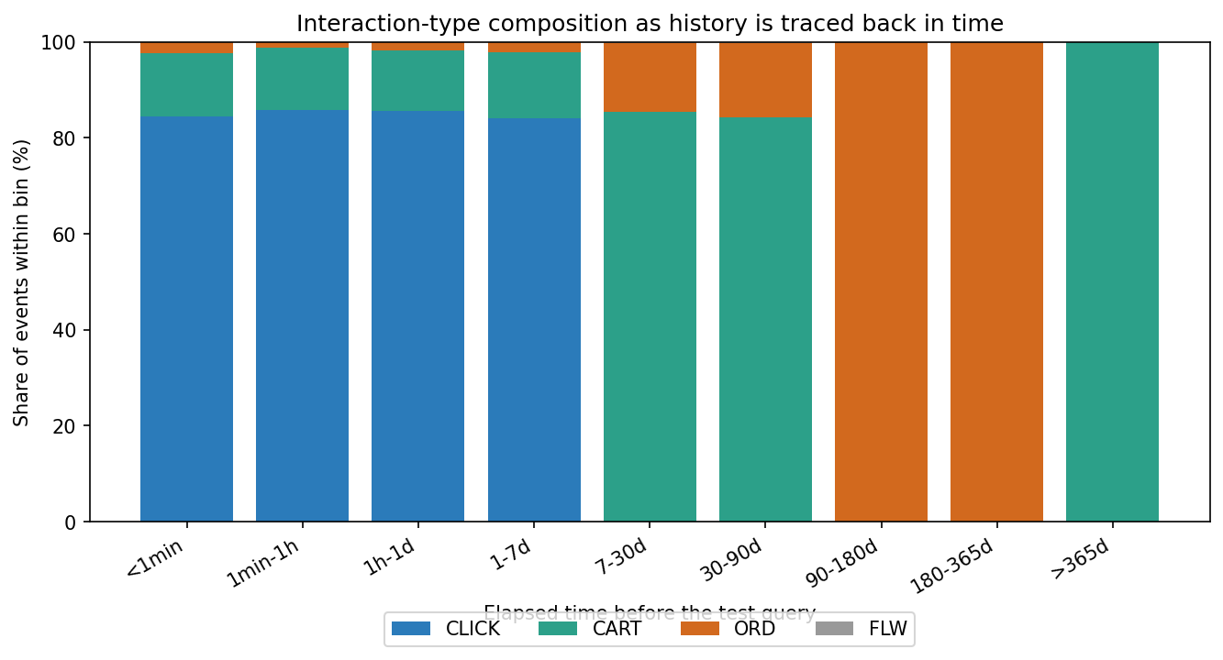
Figure 1. Interaction-type composition as history is traced back in time (full data).
A 1-day-resolution scan pins exact cut-offs: clicks vanish between day 6 (520,760 clicks) and day 7 (5 clicks); carts collapse between day 85 (100,902) and day 90 (365); orders persist to ~1 year. This is not user behaviour — it is a data-retention policy: JD keeps ephemeral clicks ~7 days, mid-value carts ~90 days, and high-value transactions ≥1 year. The millions of 'orders/carts with no clicks' the instructor highlighted are simply the long tail of history, where only durable signals survive.
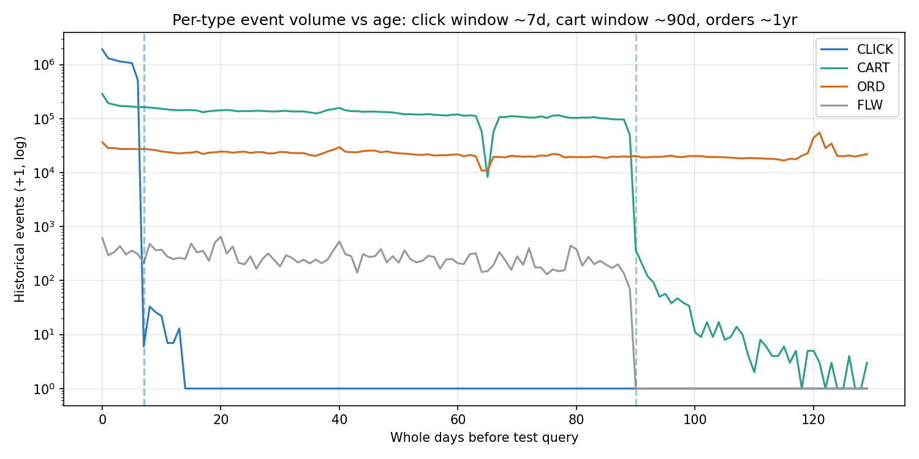
Figure 2. Per-type event volume by age (log scale): click ~7d, cart ~90d, order ~1yr retention.

1.2 Modelling implications (how the finding informs features)
- Confound awareness. Interaction TYPE is confounded with RECENCY. Weighting ORD>CART>CLICK as pure 'intent intensity' would in fact encode 'old vs recent'. We therefore never treat type as a standalone preference scale.
- No false negatives. Absence of clicks in old history is a logging artifact, not 'this user never clicks'. Old windows must not be read as negative click evidence.
- Dual horizon. Fields play distinct roles. Recent clicks/carts (≤7–90 d) = short-term intent for the CURRENT query; old orders = long-term brand/category preference. We build two separate history representations.
- Signal reality-check. Content relevance is weak via anonymised term-IDs. Exact query↔name token overlap is ~0.0002 on average and, alone, ranks no better than random (NDCG 0.087). Category/brand affinity and popularity carry the personalising signal instead.

1.3 Engineered feature set
Features are grouped by the role established above. Popularity priors are computed on TRAIN histories only (no label leakage); history features use each record's own preceding events.
Group | Representative features | Rationale
Content relevance | ov_name, ov_cat, ov_brand, jacc_name, query_len | Query↔candidate token overlap (weak but non-zero)
Popularity prior | pop_wid, pop_brand, pop_cate3 (log, train-only) | Head-vs-long-tail exposure prior
Short-term intent | short_cat_hit, short_brand_hit, aff_cat_decay (τ=30d), h_n_recent7 | Recent (≤7d) clicks/carts → current intent
Long-term preference | long_cat_hit, long_brand_hit, h_n_ord | Order-history category/brand affinity
Re-engagement | seen_before, h_min_elapsed | Has user touched this exact item / how recently
User activity | h_len, h_n_click, h_n_cart, h_n_distinct_c3, h_queryless | Activity level & diversity
Feature means by label confirm the design: long-term category affinity (long_cat_hit) is highest for purchases (0.12 vs ~0.05 for clicks/carts), while short-term affinity dominates clicks/carts — exactly the distinct-roles hypothesis showing up in the data before any model is trained.

Section 2 — Models and Performance

2.1 Task set-up, splits and metrics
Each record is one query with its candidate slate and ordinal labels, so the task is slate re-ranking: the slate already contains the negatives (97.9% label 0), and catalogue-wide negative sampling is unnecessary. We sample 20,000 users (seed 42; 1.78M candidate pairs, positive rate 2.05%, matching the full-data 2.07%) and split by session 70/15/15 into train/val/test. Metrics are computed per query over sessions containing ≥1 positive (n=2,965 test). Crucially, because the first listed candidate is positive in 98.8% of slates (interim §2.2.1), we break ranking ties with a fixed-seed random key so candidate POSITION cannot leak — without this guard a constant scorer spuriously reaches NDCG 0.97.
Metric | Definition (course Topic 4)
NDCG@10 | Σ(2^rel−1)/log2(rank+1) over top-10, normalised by ideal DCG; rel = ordinal label
MRR@200 | Reciprocal rank of the first positive (label>0) within top-200
P@1 | Top-1 candidate is a positive
HR@10 | Any positive within top-10

2.2 Models
- Random: ranks the slate by a random key (floor).
- Popularity: ranks by log popularity prior (non-personalised).
- Content / relevance-only: query↔candidate token overlap only.
- Matrix Factorisation: 64-factor TruncatedSVD on the user×historical-item implicit matrix; cold candidates have no factor (NCF/NMF family).
- NCF (neural): GMF+MLP embeddings over (user, item) ids, BCE on positives (course Topic 6 / Basic Recommenders).
- LambdaMART: LightGBM lambdarank over all engineered features, label gains [0,1,3,7] (learning-to-rank).
- DHAR: our architecture (below).
DHAR — Dual-Horizon Attention Ranker. Candidate category/brand embeddings form an attention query that attends separately over (a) the user's RECENT (≤7d) history-category sequence — short-term intent — and (b) the ORDER-history category sequence — long-term preference. The two context vectors are fused with candidate embeddings and the engineered features in an MLP head, trained listwise (softmax cross-entropy with ordinal label gains) per slate on Apple MPS. The architecture is a direct materialisation of the §1 finding: two retention horizons, two towers, one attention each.
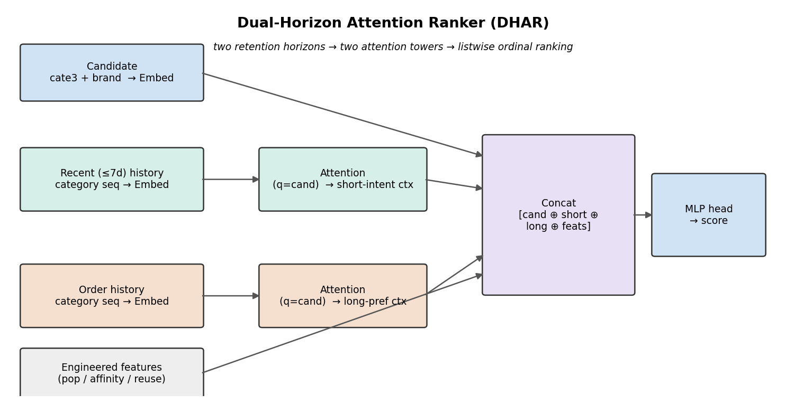
Figure 3. DHAR architecture: two retention horizons → two candidate-category attention towers → listwise ordinal ranking.

2.3 Results
Model | NDCG@10 | MRR@200 | P@1 | HR@10
Random | 0.083 | 0.102 | 0.033 | 0.227
NCF (ID-based CF) | 0.086 | 0.104 | 0.032 | 0.230
Content / relevance-only | 0.087 | 0.108 | 0.039 | 0.232
Popularity | 0.270 | 0.283 | 0.167 | 0.518
Matrix Factorisation (SVD) | 0.274 | 0.289 | 0.170 | 0.518
LambdaMART (features) | 0.313 | 0.325 | 0.204 | 0.579
DHAR (ours) | 0.336 | 0.351 | 0.229 | 0.603
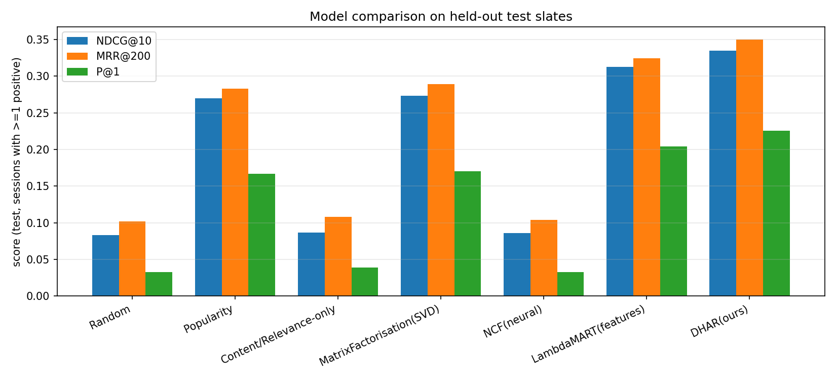
Figure 4. Model comparison on held-out test slates.
Reading the table. (1) Both CF baselines (NCF, SVD-cold) sit at the random floor on cold candidates — the structural gap. (2) Popularity is the real workhorse but saturates. (3) Feature-based LambdaMART adds personalised lift; (4) DHAR's horizon separation adds a further +0.023 NDCG@10 over LambdaMART, the best of all models on every metric.
Training vs test (overfitting check). Popularity 0.292→0.270; LambdaMART 0.394→0.313 (gap 0.081); DHAR 0.349→0.336 (gap 0.013). The dual-horizon model not only scores highest on test but also generalises markedly better than the gradient-boosted ranker, whose larger train–test gap reflects the popularity/ID features it memorises; DHAR's category-attention towers are more transferable.

Section 3 — Contribution and Justification

3.1 Self-Evaluation Table
Contribution aspect | Effort | Effectiveness | Evidence
1. Data understanding, rich-signal use & feature engineering | Optional | Optional | Full-data temporal retention analysis (§1.1); horizon-aware features (§1.3)
2. Prior baseline benchmarking & gap diagnosis | Optional | Optional | NCF & SVD reproduced; cold-item & new-query failure quantified (§2.3, §3.3)
3. Designing/adapting recommender architectures | Optional | Optional | Dual-Horizon Attention Ranker built from the retention finding (§2.2)
4. Model diagnostics, error analysis & insights | Optional | Optional | Warm/cold & history segments, rank-by-type, ablation (§3.4)
5. Smart use of AI tools & critical collaboration | Optional | Optional | AI Interaction Log (Section 4)
('Optional' = the advanced tier of the rubric, justified by the narrative below.)

3.2 Feature engineering & rich-signal utilisation (Aspect 1)
Rather than collapsing interactions into binary pairs, we exploited the raw multi-behaviour, timestamped logs and impression slates. The temporal retention discovery (§1.1) is the project's analytical core: it explains a dataset anomaly, is computed on all 26.7M events with exact cut-offs, and drives every downstream feature. We separate short-term intent from long-term preference and compute recency-decayed category/brand affinities — domain-informed features that a naive type-weighting would get backwards.

3.3 Baseline benchmarking & gap diagnosis (Aspect 2)
We reproduced the CF family and diagnosed WHY it fails here rather than merely reporting low numbers: (i) each user has one test record with an almost-always-new query, so user-ID factors cannot transfer; (ii) 80.5% of candidate products never appear in any history, so item factors are undefined — on test, only 14.5% of candidates are 'warm'. NCF therefore equals random (0.086) and SVD only reaches popularity level. This gap — new-query generalisation under massive item cold-start — is precisely what our content/affinity features and DHAR target.

3.4 Diagnostics, error analysis & business insight (Aspect 4)
Segment | NDCG@10 | Read
Warm candidate (seen in train hist) | 0.586 | Model ranks well when it has a prior
Cold candidate (unseen) | 0.180 | Cold-product ceiling — the binding limitation
Cold users (<3 events) | 0.323 | Popularity/content carry new users
Long-history users (>100) | 0.311 | No degradation with history length
Rank-of-positive by interaction type (lower is better): eventual purchases land at median rank 7, carts at 15, clicks at 26. The model is most confident exactly where business value is highest — because purchases align with the stable long-term order signal, while clicks are noisier short-term intent. Ablating the temporal-aware features costs +0.013 NDCG@10, confirming they contribute beyond popularity. Business takeaway: (a) invest in cold-product content representations (the 0.586→0.180 gap is the main lever); (b) a two-horizon model should drive purchase-oriented ranking, while a lighter recency model suffices for click-through objectives.
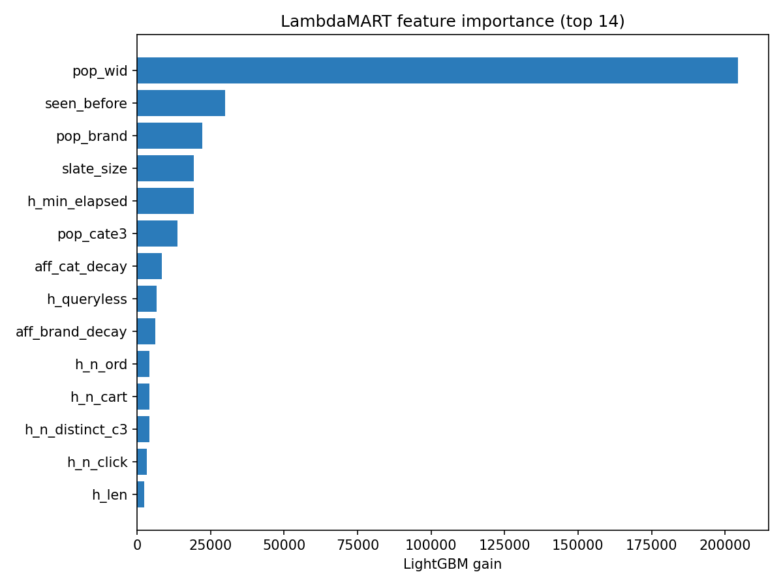
Figure 5. LambdaMART feature importance: popularity, re-engagement and horizon/affinity features dominate.

3.5 Reproducibility & pipeline (Aspect: source code)
The pipeline is modular and runs end-to-end: step1 temporal analysis (full data), step2 dataset build, step3 features, step4 baselines+LambdaMART, step5 neural (DHAR, NCF), step6 diagnostics+ablation. N_USERS is a single knob to scale from the 20k-user laptop run to the full data on Colab/GPU.

Section 4 — AI Interaction Log (Appendix)
Core prompt / objective | AI output summary | Our critical evaluation | Refinement & final action
Why do carts/orders outnumber clicks, and what does tracing history back in time reveal? | Suggested converting interval seconds to elapsed days and cross-tabulating type vs age. | Correct direction but could not know JD's retention policy; risk of over-reading medians. | We computed suffix-sum elapsed days on all 26.7M events and found exact 7d/90d/1yr cut-offs.
How should ordinal labels 0/1/2/3 be handled for ranking? | Proposed cumulative-link ordinal regression and listwise losses with label gains. | Cumulative-link assumes pure intensity ordering — but §1 shows type≈recency confound. | Adopted listwise softmax with ordinal gains [0,1,3,7]; avoided type-as-intensity weighting.
Our content/relevance baseline scored NDCG 0.97 — is that right? | Flagged possible tie-breaking/position leakage given the 98.8% first-position positive. | Matched the interim's own warning; a stable sort was leaking candidate order. | Added fixed-seed random tie-breaking in evaluation; honest score dropped to 0.087.
Design an architecture that uses the retention finding. | Suggested a two-tower / dual-horizon encoder with attention over history. | Generic; needed category-level attention and MPS-efficient padded-slate batching. | Implemented DHAR with per-horizon candidate-category attention; vectorised for MPS.

Section 5 — References
- Liu, J., Dou, Z., Tang, G., & Xu, S. (2023). JDsearch: A Personalized Product Search Dataset with Real Queries and Full Interactions. Proceedings of SIGIR 2023 (pp. 2945–2952). ACM. https://doi.org/10.1145/3539618.3591900
- JDsearch Dataset GitHub Repository. https://github.com/rucliujn/JDsearch
- He, X., Liao, L., Zhang, H., Nie, L., Hu, X., & Chua, T.-S. (2017). Neural Collaborative Filtering. WWW 2017.
- Rendle, S., Freudenthaler, C., Gantner, Z., & Schmidt-Thieme, L. (2009). BPR: Bayesian Personalized Ranking from Implicit Feedback. UAI 2009.
- Burges, C. (2010). From RankNet to LambdaRank to LambdaMART: An Overview. Microsoft Research Technical Report.
- Ke, G., et al. (2017). LightGBM: A Highly Efficient Gradient Boosting Decision Tree. NeurIPS 2017.
- BT4222 Lecture Topics 4 (Evaluation), 6 (Embedding), 7 (RNN & Transformer); Ordinal Classification Guide, 2026-27 T1.

